

**Student Project**

**Radio Resource Assignment for LTE-Advanced**

**Volha Leusha**

Matriculation Number: 21043638

Examiner: Prof. Dr.-Ing. Timm Giel

Second Examiner: Dr. Lother Kreft

Supervisor: Maciej Mühleisen

**Declaration of Authorship**

I declare that the work presented here is, to the best of my knowledge and belief, original and the results of my investigations, except as acknowledged, and has not been submitted, either in part or whole, for a degree at this or any other University.

Formulations and ideas taken from other resources are cited as such. This work has not been published.

Hamburg, 1th June 2013

**Abstract**

Continuously growing demand in more sophisticated mobile technologies pushes the development of cellular networks to the direction of fourth-generation mobile systems. The main issues that always are the bottleneck in mobile technologies are poor indoor coverage and restricted frequency band. As an appropriate pathloss model to evaluate this problem Indoor Hotspot Non line-of-site (InH NLoS) scenario is chosen. Moreover, frequency reuse of one is assumed.

The improvement of Radio Resource Management Procedures, that is one of the key features of LTE- Advanced, will allow to increase performance of the system. Scheduling in this case plays a fundamental role as it is responsible for assignment of radio resources among users and base stations. However, scheduling procedures should be chosen thoroughly, so that they satisfy QoS requirements and adapt to changing channel conditions.

This thesis provides the analysis of different radio resource allocation strategies. The first part of the thesis contains theoretical background information for the better understanding of the simulation model and results.

The model of the network is simulated in MatLab. The parameters defined by ITU-R for IMT-Advanced are used. Simulation is done for different configurations of simulation scenarios, namely number of cells in the system, number of users per cell, inter-cell distances of users around the cell and distance between base stations. It allows to make approximately realistic estimation of the performance of strategies under different conditions.

Performance of radio resource strategies is evaluated relatively to each other, comparing Runtime and Cell Spectral Efficiency metrics.

**Table of Contents**

1. **List of figures 5**
2. **List of tables 7**
3. **List of abbreviations 8**
4. **Introduction 9**
   1. Motivation…………………………………………………………………………………………………………………….9
   2. Work Structure……………………………………………………………………………………………………………..9
5. **LTE-Advanced Technology 11** 
   1. Evolution of LTE technology………………………………………………………………………………………..11
   2. Overview of LTE technology………………………………………………………………………………………..11
      1. LTE system architecture……………………………………………………………………………………11
      2. LTE radio interface architecture……………………………………………………………………….12
      3. Physical layer……………………………………………………………………………………………….…..13
      4. Radio resource management……………………………………………………………………….…..15
   3. Overview of LTE release 10…………………………………………………………………………………….…..16
6. **Scheduling in LTE 18**
   1. Scheduling in LTE systems – general information ………………………………………………….…..18
      1. Key design aspects……………………………………………………………………………………….…..18
      2. Key practical limitations……………………………………………………………………………….….19
      3. Dynamic and semi-persistent scheduling………………………………………………………..20
   2. Scheduling strategies for LTE……………………………………………………………………………………….20
   3. Degrees of freedom for uplink radio resource scheduling process………………………………23
      1. Number of RBs per UT………………………………………………………………………………………23
      2. Transmission power………………………………………………………………………………………….24
      3. MCS………………………………………………………………………………………………………………....24
      4. Which RBs to which UT…………………………………………………………………………………….26
7. **Radio resource assignment algorithms 28**
   1. Assignment algorithms……………………………………………………………………………………………....28
   2. Two-dimensional assignment………………………………………………………………………………….....28
   3. Multidimensional assignment………………………………………………………………………………….....30
   4. Hungarian or Munkres algorithm…………………………………………………………………………….....31
      1. Implementation of Hungarian or Munkres algorithm………………………………….......31
      2. Computational complexity of Hungarian or Munkres algorithm………………….......33
   5. Greedy heuristic algorithm………………….....………………………………………………………………....33
      1. Implementation of Greedy heuristic algorithm…………………………………………………34
      2. Computational complexity of Greedy heuristic algorithm…………………………………35
   6. Maximum Regret heuristics algorithms……………………………………………………………………….35
      1. Implementation of Maximum Regret heuristics algorithm……………………………….35
      2. Computational complexity of Maximum Regret heuristics algorithm……………….39
   7. Conclusions………………………………………………………………………………………..……………………….40
8. **Simulation Scenario 43**
   1. Simulation scenario……………………………………………………………………………..……………………..43
   2. Simulation parameters and configurations…………………………………………..……………….…...44
9. **Simulation Results 46**
   1. Uplink throughput comparison…………………………………………………………..……………………….46
   2. Cell spectral efficiency………………………………………………………………………………………………..47
   3. Runtime……………………………………………………………………………………………………………………..56
10. **Summary 59**
    1. Conclusions………………………………………….……………………………………………………………………..59
    2. Outlook……….……………………………………….……………………………………………………………………..59
11. **Bibliography 61**

**List of Figures**

2.1: Service Architecture Evolution for LTE technology……………………………………………………………12

2.2: LTE Protocol Architecture (Downlink) ………………………………………………………………………………13

2.3: OFDMA and SC-FDMA………………………………………………………………………………………………………14

2.4: Structure of transmitted signal…………………………………………………………………………………………14

2.5: The LTE subframe structure……………………………………………………………………………………………..15

2.6: Interaction of RRM procedures………………………………………………………………………………………..16

2.7: Classification of Heterogeneous Nodes…………………………………………………………………………….17

3.1: Resource Fairness…………………………………………………………………………………………………………….24

3.2: Example of scheduling for two-cells scenario…………………………………………………………………..25

3.3: Mapping of SINR to Data Rate………………………………………………………………………………………….28

4.1: Example for the two-dimensional problem with N UTs…………………………………………………….31

4.2: Example for the multi-dimensional problem with N UTs………………………………………………….31

4.3: Three-cell problem with N UTs in each cell………………………………………………………………………35

4.4: Maximum Regret Multi Dimensional ……………….………………………………………………………………38

4.5: Maximum Regret Divided and Maximum Regret User Oriented Method………………………….39

4.6 : Number of operations versus number of UTs for two and three BSs………………………………..42

4.7: Number of operations versus number of UTs for Maximum Regret Algorithm with Different

Number of Fixed Index Positions (seven BS) …………………………..………………………………………43

4.8: Computational complexity of Maximum Regret versus Brute Force…………………………………43

5.1: Simulation scenario with three cells and two UTs in each cell………………………………………….44

5.2: Example scenario for three Cells, 200 UTs in each cell and rcell=100m, dinter=0m……………..45

6.1: CDF of the Uplink Throughput in two cell scenario with dinter=-75m…………………………………47

6.2: CDF of the Unlink Throughput for different number of cells…………………………………………….49

6.3: CSE in two cell scenario versus dinter…………………………………………………………………………………50

6.4: CSE in four UT scenario versus dinter………………………………………………………………………………….50

6.5: Percentage of Victories versus Number of UTs in two cell scenario for different Inter-cell

Edge Distances………………………………………………………………………………………………………………..51

6.6: Percentage of Victories versus Number of UTs in three cell scenario for different Inter-cell

Edge Distances…………………………………………………………………………………………………………………52

6.7: Percentage of Victories versus Inter-cell Edge Distances in Four Cell Scenario for different

Number of UTs……………….………………………………………………………………………………………………..53

6.8: Percentage of Victories versus Number of drops in three cell scenario with four UTs and

dinter=-50m………………….……………………………………………………………………………………………………54

6.9: Gain over Random Strategy versus Number of UTs in two cell scenario for different

Inter-cell Edge Distances………………………………………….………………………………………………………54

6.10: Gain over Random Strategy versus Number of UTs in three and four cell scenario and

dinter=-50m……………………………………………………………………………..……………………………………..55

6.11: Percentage of Victories versus Number of UTs in three and four cell scenario with

dinter=-50m……………………………………………………………………………………………………………………..56

6.12: Gain over Random Strategy versus Number of cells for four UTs in the cell……………………56

6.13: Runtime versus Number of UTs in the cell………………………………………………………………………58

**List of Tables**

3.1 : Channel-unaware strategies…………………………………………………………………………………………….21

3.2: Channel-aware strategies………………………………………………………………………………………………….22

3.1: CQI table……………………………………………………………………………………………………………………………26

4.1: Difference between algorithms…………………………………………………………………………………………41

4.2: Breakeven point for Greedy and Maximum Regret…………………………………………………………..42

5.1: Configuration and Simulation Parameters…………………………………………………………………………46

**List of Abbreviations**

3GPP 3rd Generation Partnership Project

AMC Adaptive Modulation and Coding

ARQ Automatic Repeat Request

BET Blind Equal Throughput

BLER Block Error Rate

BS Base Station

CSE Cell Spectral Efficiency

CQI Channel Quality Indicator

FIFO First In First Out

EDF Earliest Deadline First

eNB Enhanced NodeB

FDD Frequency-division duplex

HARQ Hybrid Automatic Retransmission Request

ITU-R International Telecommunication Union Radiocommunication Sector

LTE Long Term Evolution

MAC Medium Access Control

MT Maximum Throughput

MCS Modulation and Coding Scheme

MME Mobility Management Entity

OFDM Orthogonal Frequency Division Multiplexing

OFDMA Orthogonal Frequency Division Multiple Access

PDCP Packet Data Convergence Protocol

PF Proportional Fair

PHY Physical Layer

PGW Packet Data Network Gateway

QoS Quality of Service

RLC Radio Link Control

RR Round Robin

SC-FDMA Single-Carrier Frequency-Division Multiple Access

SINR Signal to Interference plus Noise Ratio

SGW Serving Gateway

TB Transmission Block

TDD Time-division duplex

UT User Terminal

WFQ Weighted fair Queuing

**Introduction**

The chapter provides motivation and structure of the thesis. It gives an overview of the problem solved and shows the importance of the thesis.

* 1. **Motivation**

Growing demand in traffic volume, not only for home applications, but also for mobile devices, is the main reason for the development and standardization of a new generation of mobile communication systems. Answering to this demand, in 2008 International Telecommunication Union Radiocommunication Sector (ITU-R) published the Circular Letter calling for submission of a new radio interface technology [1]. In June 2009, 3rd Generation Partnership Project (3GPP) introduced the Long Term Evolution specifications [2].

One of the goals of LTE -Advanced is to maximize the Cell Spectral Efficiency (CSE) [3]. The possible solution to achieve this is to use frequency reuse -1, when whole available frequencies for every base station are used. However, co-channel interference becomes more critical in this case and intelligent radio resource management is required. The usage of an efficient scheduling procedure can increase significantly the performance of the system.

In this thesis indoor coverage scenario, that is one of the main issues for every wireless system, was investigated. Importance of this scenario was shown in different studies. 45% of households and 30% of businesses pointed out that they suffer from the poor communication quality inside buildings [4].

* 1. **Work Structure**

In Chapter 2 the brief overview of LTE and LTE-Advanced technologies is provided with the focus on resource management, targeting to create a theoretical basis for further understanding of the following chapters.

In Chapter 3 scheduling procedure in LTE is described. Key design aspects and possible difficulties in creation of an efficient scheduling are pointed out. The chapter ends with the description of degrees of freedom that the assignment of radio resources during the resource scheduling process has. Additionally are described parameters involved in further evaluation of simulation results.

Chapter 4 gives an overview of all radio resource assignment algorithms used in the thesis. The algorithms implementation is described step-by-step for Hungarian, Maximum Regret and Greedy algorithms. Theoretical computational complexity is shown and compared for every algorithm relatively to others for different number of cells and user terminals (UTs) in the system.

In Chapter 5 simulation model, its parameters and configurations are described. Chapter 6 provides simulation results produced in MatLab. The strategies develop in the thesis are compared with Random. Performance of strategies is evaluated analyzing the impact on the throughput and computational runtime.

Chapter 7 provides a conclusion and an outlook for future research.

**LTE-Advanced Technology**

This chapter contains general theoretical information about features of LTE and LTE-Advanced technologies, creating a base for better understanding of the following chapters.

* 1. **Evolution of LTE Technology**

LTE- Advanced, or LTE Release 10, is not a new technology, but the further evolution of LTE technologies – Release 8 and 9. Therefore, LTE-Advanced contains all the features of predecessors and some additional improvements.

* 1. **Overview of LTE Technology**

LTE technology was designed to satisfy fast growing demand in mobile communication by the means of low latency, increased data rates, improved spectral efficiency if compared to previous generation technologies that mostly supported voice applications. To achieve these targets, it is necessary to design an effective resource allocation, radio resource management, scheduling procedures etc. In this section a brief overview on main LTE specifications is presented.

* + 1. **LTE System Architecture**

The architecture of LTE system is known as “Service Architecture Evolution” and is shown in Figure 2.1 [4].

Service Architecture Evolution consists of Evolved Packet Core and Evolved-Universal Terrestrial Radio Access Network and is based on a flat architecture.

Evolved Packet Core includes Mobility Management Entity, Serving Gateway and Packet Data Network Gateway.

* Mobility Management Entity (MME) is responsible for mobility, intra-LTE handover and tracking procedures during connection establishment.
* Serving Gateway (SGW) functions are: routing and forwarding of data packets, and managing handover between LTE and other 3GPP technologies.
* Packet Data Network Gateway (PGW) is performing as the connecting unit of LTE with other IP networks.

Radio Access Network includes eNodeBs (eNB) and User Equipment (UE). eNBs are connected with MME as well as with each other, allowing the speed up of signaling procedures. Unique from other cellular networks structures, eNB is responsible for radio resource management and control of radio interface at the same time.

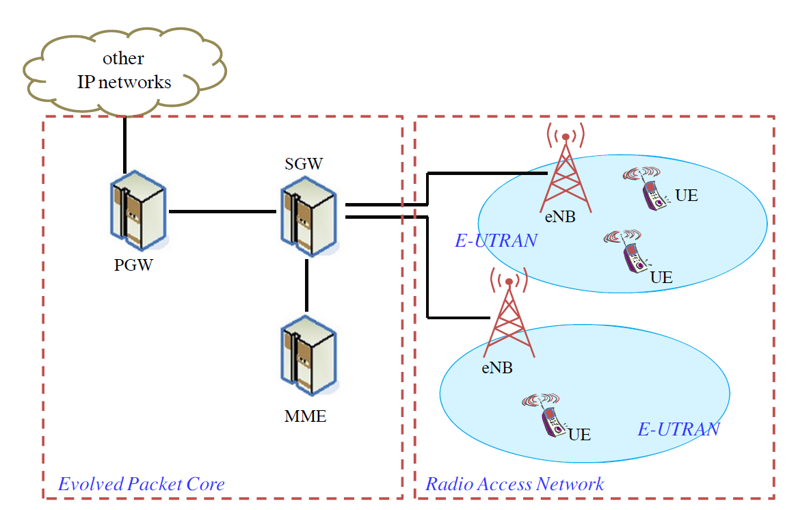

Figure 2.1: Service Architecture Evolution for LTE technology [4]

* + 1. **LTE Radio Interface Architecture**

The protocol structure for LTE downlink is illustrated in Figure 2.2. Not all the modules are applicable for every situation. For example, in broadcasting, MAC scheduling. Uplink structure is similar to downlink with differences in transport format selection and multi-antenna transmission [5].

As shown in the Figure 2.2, IP packets, before transmission, have to pass through protocol entries. This is briefly discussed below:

* Packet Data Convergence Protocol (PDCP) is responsible for header compression. It reduces the number of bits to transmit.
* Radio Link Control (RLC) operates segmentation and concatenation, handles retransmission, and in-sequence delivery to higher layers.
* Physical Layer (PHY) is responsible for coding, modulation, multi-antenna mapping, and other physical layer functions. PHY layer structure and features are explained in section 2.2.3.
* Medium Access Control (MAC) handles hybrid-ARQ retransmissions, as well as uplink and downlink scheduling. Scheduling is performed in eNB.

MAC scheduler is described in Chapter 3 in more details.

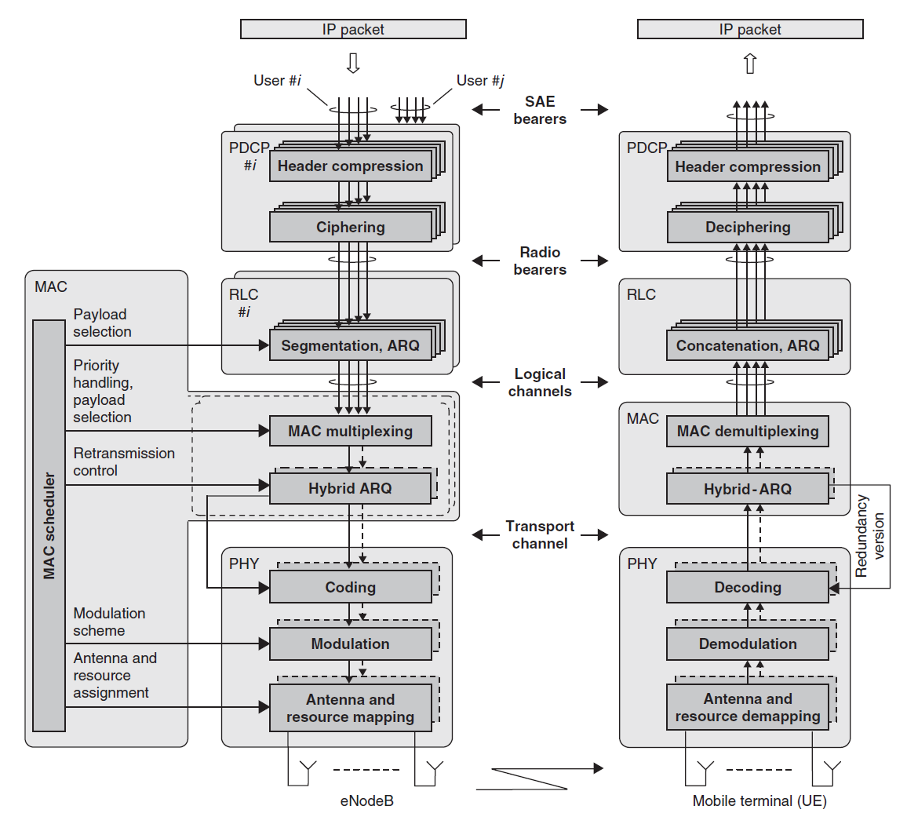

Figure 2.2: LTE Protocol Architecture (Downlink)[5]

* + 1. **Physical Layer**

On the physical layer are introduced some new for cellular networks technologies, like the Orthogonal Frequency Division Multiplexing (OFDM). The objective of OFDM is that system divides the whole bandwidth into many narrower units (sub-carriers) and transmits them in parallel. Each sub-carrier is transmitted using specific Quadrature amplitude modulation (QAM). Choice of modulation scheme depends on the signal quality [6].

According to [7], Orthogonal Frequency Division Multiple Access (OFDMA) is chosen for the downlink and Single-Carrier Frequency-Division Multiple Access (SC-FDMA) for the uplink. For downlink, frequency-selective wideband channel is divided into overlapping non-frequency selective sub-channels, whereas for uplink, singe-carrier is used for every user and division is

performed by non-overlapping sub-carriers with different Fourier coefficients (e.g. Figure 2.3) [8]. OFDMA provides required for downlink high scalability and robustness, whereas the choice of SC-FDMA for uplink is based on the power consumption efficiency, because of battery usage in mobiles.

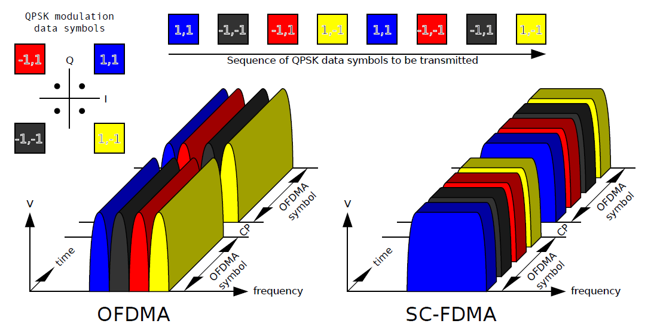

Figure 2.3: OFDMA and SC-FDMA [6]

The bandwidth in LTE can be scaled from 1.4 MHz up to 20 MHz. Frequency-division duplex (FDD) and time-division duplex (TDD) operation modes are used to separate UL and DL traffic [4]. In Figure 2.4 the structure of transmitted signal is shown. One radio frame contains 10 sub-frames or Transmission Time Intervals (TTI) with duration 1ms. The structure of sub-frames is presented in Figure 2.5 and is the same for FDD and TDD. Each sub-frame has 2 slots, or Resource Blocks (RB), each of 0.5ms with 7 or 6 OFDM symbols and 12 sub-carriers. Total number of subcarriers depends on overall transmission bandwidth. For bandwidth of 20 MHz, there will be 100 available RBs.

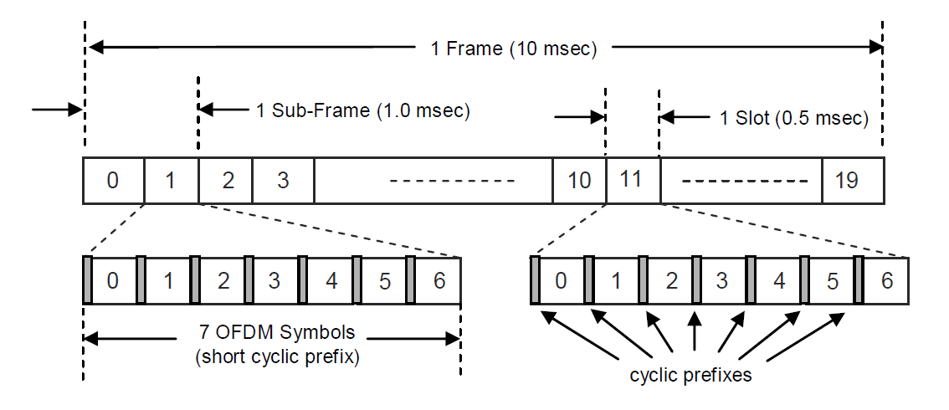

Figure 2.4: Structure of transmitted signal [6]

Each RB contains data, control and reference symbols. Reference signals can be used for demodulation purposes and measurements (e.g., reports sent by user terminals (UTs) to base stations (BSs) about channel conditions). The data transmissions are scheduled by base station [9]. The smallest resource that can be assigned to each user is usually two consecutive in time RBs.

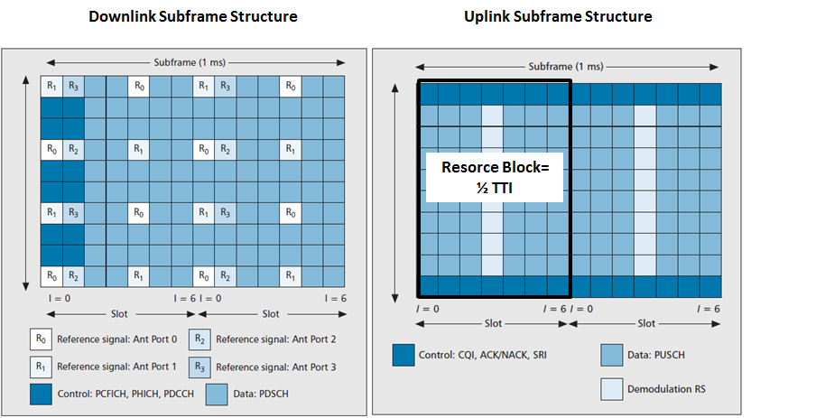

Figure 2.5: The LTE subframe structure [10]

* + 1. **Radio Resource Management**

To improve the efficiency of radio resource, usage radio resource management is performed in LTE. Radio Resource Management includes following procedures [4]:

* Channel Quality Indicator (CQI) reporting.
* Adaptive Modulation and Coding (AMC) and Power control.
* Physical channels.
* Hybrid Automatic Retransmission Request (HARQ).

In Figure 2.6 interactions between these procedures are shown. Physical channels and HARQ explanation is not required for this work. The reader should refer to [6] for more details.

**CQI Reporting**

CQI reporting provides opportunity to estimate quality of downlink channel in eNB based on experienced Signal to Interference plus Noise Ratio (SINR). However, there exists a tradeoff

between good quality estimation and signaling overhead. If too many bits are used for signaling it will decrease amount of bits available for data transmission.

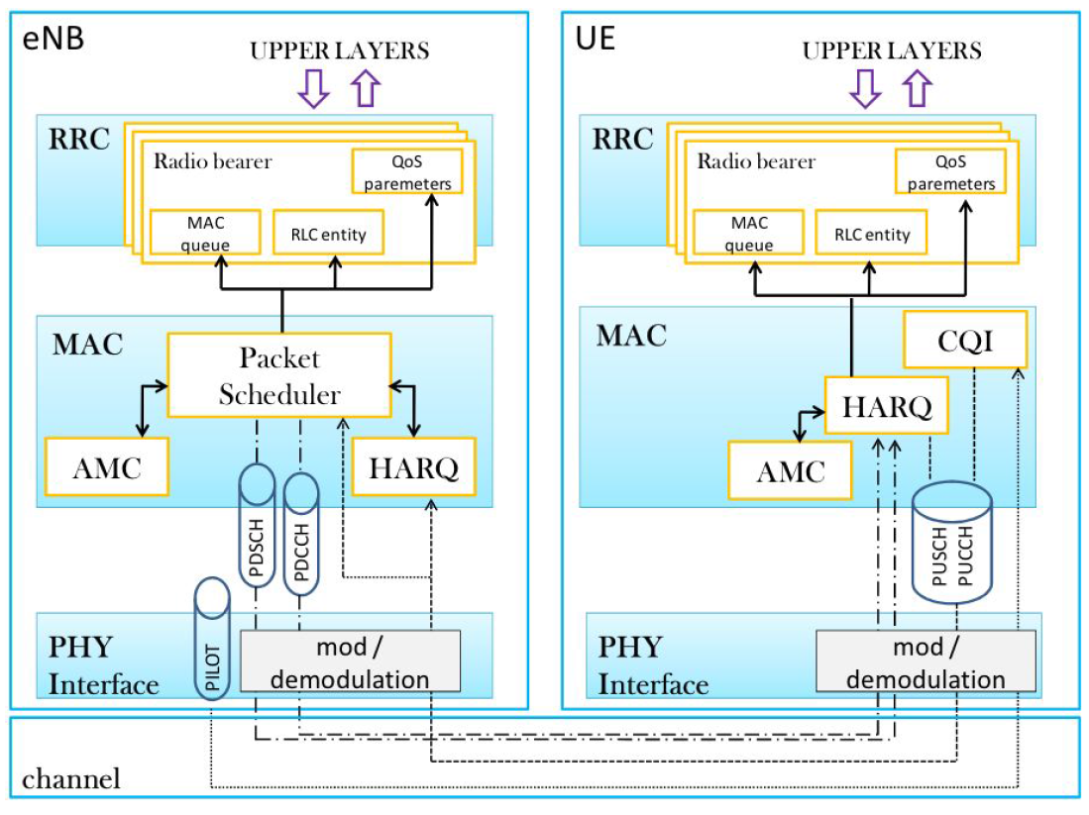

Figure 2.6: Interaction of RRM procedures [4].

**AMC and Power Control**

With a help of CQI reporting AMC module selects a relevant Modulation and Coding Scheme (MCS) based on maximization of throughput with given Block Error Rate (BLER). Details about AMC and power control are presented in Chapter 3.

* 1. **Overview of LTE Release 10**

As was mentioned above LTE-Advanced is the evolution of LTE with some additional improvements that are described below: [9], [10].

**Enhanced multi-antenna support**

LTE-Advanced technology supports up to eight antennas in downlink. This results in spatial multiplexing and increases peak data rates. Additional feature that is also improving performance is that multiple antennas allow the beam forming of the common antenna pattern.

**Carrier Aggregation**

The bandwidth in LTE can be scaled up to 20 MHz. This number is extended in LTE Release 10 to 100 MHz by means of carrier aggregation on the physical layer. Here multiple component carriers are joined jointed to use for one mobile terminal. For the data rate of 20MHz and with four-layer spatial multiplexing the bandwidth is approximately 300 Mb/s. But with carrier aggregation there is a possibility to increase this value up to 5*300 Mb/s. Consequently, using spatial multiplexing and carrier aggregation together the peak data rate of 1.5 Gb/s is achieved. This is beyond LTE-Advances requirements.

**Heterogeneous deployments**

The macrocell network in LTE Release 10 consists of low-power nodes: micro eNBs, pico eNBs,

home eNBs (for femtocells), relays, and distributed antenna systems (DASs).Classification of heterogeneous nodes is given in Figure 2.7. The denser infrastructure provides possibility to support very high end-user data rates, at the same time increasing the overall capacity, as the number of cells increases. Such cells operate in smaller distances and results in high interference.

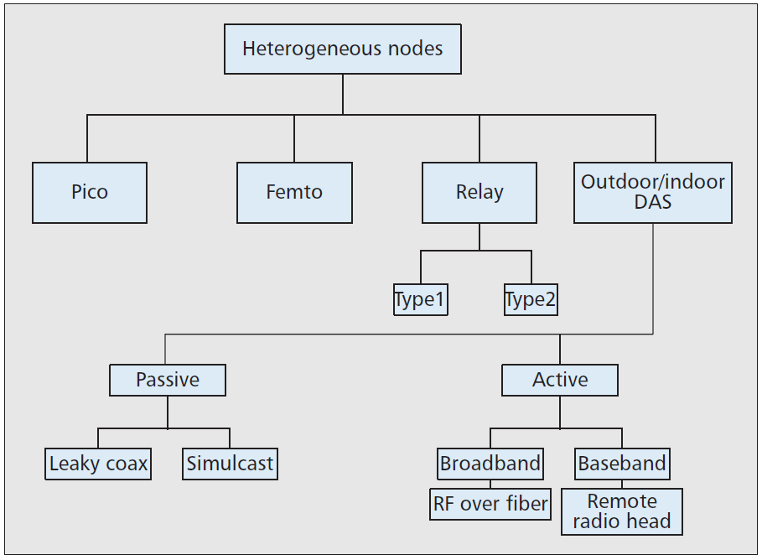

Figure 2.7: Classification of Heterogeneous Nodes [10]

**Scheduling in LTE**

In this chapter details about the scheduling in LTE systems are presented. It starts with general information about scheduling organization and proceeds with key design aspects and possible scheduling strategies. This chapter also describes four degrees of freedom during the resource scheduling process.

* 1. **Scheduling in LTE Systems- General Information**

Scheduling performs distribution of radio resources and plays an essential role in LTE systems. This distribution is done by eNB and targets sharing of available spectrum among users taking into account user satisfaction [11]. As shown in the Figure 2.2, the scheduling is done in MAC layer, but it also affects PHY layer and RLC.

The decision about resource allocation of each user is usually formed by comparison of metrics and can be formulated as [4]:



(3.1)

*where k-th resource block is assigned to j-th user when its metrics mj,k is maximized*

The evaluation of these metrics is based on different aspects, such as resource allocation history, quality of service requirements, CQI reports about channel quality, buffer state and others.

For every TTI the scheduler makes the decision about resource assignment for the following TTI and sends to UTs information about RBs allocated to them.

The whole process for downlink scheduling can be described in steps as follows:

1. *User decodes reference signals, computes CQI and sends it back to eNB.*
2. *Using CQI report, eNB creates allocation mask, containing allocation decisions.*
3. *AMC module selects best MCS for scheduled users.*
4. *eNB sends to each user information about allocated RBs and selected for them MCS.*
5. *Each user reads information, sent by eNB, and in the case it has been scheduled, uses this information for the transmission.*

For uplink the same scheduling steps can be used with the difference that eNB does not need feedback from users to get information about uplink channel quality.

* + 1. **Key Design Aspects**

The decision about radio resource assignment is based on the tradeoff between computational complexity and solution optimization. Therefore, during allocation strategy design following aspects should be taken into account [4]:

**Complexity and Scalability**

As was pointed above, the decision about resource allocation should be made every TTI, the duration of which is 1 ms. Consequently, computational complexity, specifically processing time and memory size, are important parameters in effective algorithm creation. If cells are coordinated, optimal solution finding is becoming more complex for high number of cells and users in the system. This tradeoff is explained in chapter 4 in further detail.

**Spectral efficiency**

One of the main goals of LTE is to achieve an effective usage of radio resources. There are several indicators of how utility effectiveness can be measured. The most common is- maximization of spectral efficiency. There also exist other indicators, such as maximization of number of users served in the given time frame and etc.

**Fairness**

Maximization of common throughput is not always leading to the fair distribution of resources among users. Fairness is also an essential factor because, at least, the minimum performance should be provided for users experiencing bad channel conditions.

**Quality of Service (QoS) Provisioning**

QoS requirements should be considered in design of the scheduler as it is an important topic for mobile technologies. Examples of QoS requirements are: packet loss rate and minimum guaranteed bitrate.

* + 1. **Key Practical Limitations**

Some practical limitations that can be faced designing of an effective scheduler are listed below [4]:

* Uplink uses SC-FDMA for transmission, therefore unlike downlink with OFDMA method, each user is allowed to transmit only in single carrier mode. The scheduler cannot choose among best available RBs, but has to assign the contiguous ones.
* Radio resources, dedicated for controlling, are limited (up to 3 OFDM symbols from 14 available). There are several ways to reduce control overhead. For instance, lower bit rate can be achieved if to assign only contiguous RBs to the same user.
* It is not always possible to supply eNB with adequate measurement of the channel quality. As was already mentioned, for downlink users send CQI to eNB, but in the case of uplink transmission, eNB uses transmitted by UT reference signals to make channel quality estimation. Consequently, for wideband CQI , with the single CQI value for all the frequencies, there multi-user diversity gain will become zero as channel condition estimation does not impact any more.
* Power consumption limitations.
  + 1. **Dynamic and Semi-Persistent Scheduling**

In dynamic scheduling good multi-user diversity gain can be achieved. However, it will result in unacceptable control overhead because every TTI scheduling messages will need to be forwarded to every user. When there are a lot of users in the system or high amounts of data needs to be transmitted this issue becomes critical. If high portion of radio resources are assigned for control information, control information transmission will perform as a bottleneck and reduce the QoS [12].

Semi-persistent scheduling is an alternative solution to dynamic scheduling. It is based on the principle that assigned to user frequency will persist until it will not be changed [6]. However, this solution cannot be used in dynamic context with other flows, where spectral efficiency is important. Therefore, combination of Semi-persistent schedulers and dynamic schedulers can be used [4].

* 1. **Scheduling Strategies for LTE**

Allocation strategies can be divided into groups [4]:

* Channel-unaware.
* Channel-aware, QoS-unaware.
* Channel-aware, QoS-aware.
* Semi-persistent for VoIP support.
* Energy-aware.

Channel-unaware schedulers were mostly used in operating systems and cable networks and are presented in this chapter to give an overview. Channel aware strategies became useful for wireless systems. Appearance of LTE networks has pushed the development of schedulers even more towards advanced QoS oriented strategies [4]. The short description and general information about all strategies is presented below.

**Channel-Unaware Strategies**

Channel-unaware strategies are not useful for wireless communication, because they do not consider channel quality variations and are based on an assumption of low and time invariant error rate. In Table 3.1 some examples of channel-unaware strategies are presented.

Table 3.1 : Channel-unaware strategies

|  |  |  |
| --- | --- | --- |
| Channel-Unaware Strategy Name | Description | Metric Function |
| First In First Out (FIFO) | Users are served according to the order of request. Simple, but inefficient technique |  |
| Round Robin (RR) | The strategy is implemented by always scheduling the user which has not been scheduled for the longest time. Based on the fair sharing of time resources between users. Fairness in amount of time is achieved, but not in amount of throughput for users, as it does not take into account that users with worse channel conditions will achieve lower throughput in the same amount of time. |  |
| Blind Equal Throughput (BET) | Based on the throughput fairness. The past average throughput is stored by every user and used as a metric. Relevant improvement in fairness is observed. |  |
| Resource Preemption | Transmission queues are grouped into priority classes. Groups with high priority are served first |  |
| Weighted fair Queuing (WFQ) | Very similar to Resource Preemption, but instead of classes, user metrics is multiplied on the weight assigned to this user. Users with higher value metrics*weight are served first |  |
| Earliest Deadline First (EDF) | Each packet has to be received during defined deadline. This technique allows to avoid packet drops |  |
| 1. *mi,n – metric function of n-th user on k-th RB; t – current time; Tn – time, when request was issued by n-th user* 2. *TSn – last time when user was served* 3. *Rn(t-1) –past average throughput of n-th user in time (t-1)* 4. *Wn – weightof n-th user* 5. *Τi – delay threshold for the i-th user; Di – head of line delay,i.e. delay of first packet to be transmitted by the i-th user* | | |

**Channel-Aware, QoS-unaware Strategies**

As in LTE CQI procedure is implemented, eNB can predict maximum achievable throughput by decoding control messages and estimation of channel quality.

Some examples of channel-aware strategies are shown in Table 3.2:

Table 3.2: Channel-aware strategies

|  |  |  |
| --- | --- | --- |
| Channel-Unaware Strategy Name | Description | Metric Function |
| Maximum Throughput (MT) | This strategy targets maximization of overall cell throughput. However, fairness suffers, because cell-edge users get only a small portion of resources. |  |
| Proportional Fair (PF) Scheduler | This technique is the typical way to find an equilibrium between fairness and spectral efficiency. This is achieved by not evaluating MT and BET separately, but by the evaluation of the common product of MT and BET. |  |
| Throughput to Average | Throughput in t-th TTI is used as normalization value. The technique is a trade-off between MT and PF, The method guaranties the minimum level service to each user. Higher is the overall throughput of the user, lower is the metric for one RB. |  |
| Joint Time and Frequency Scheduler | Decision is separately made by two schedulers. Time scheduler select active users in present TTI from all users connected to the cell and frequency scheduler (FS) allocates RBs to them. This technique allows reduction in the complexity of FS |  |
| 1. *mn,k – metric function of n-th user on k-th RB; Thn,k(t) – maximum throughput expected for user n at TTI number t over the RB number k* 2. *Thn(t) – maximum throughput expected for user n at TTI number t over the entire bandwidth* | | |

**Channel-Aware, QoS-aware Strategies**

QoS aware strategies are based on the assumption that, during decision making, the scheduler will take into account minimum required performance that should be delivered to the customer. Examples of such requirements can be: guarantied data rate, delay and etc.

**Semi-Persistent Scheduling for VoIP Support**

Minimization of signaling overhead is an important requirement for VoIP flows when a high number of calls have to be served. As semi-persistent scheduling allows the reduction of resources used for signaling information, it can be used for VoIP support.

**Energy-Aware Strategies**

Energy saving problems is becoming more essential in mobile communication during last years. The scheduling strategy should not only take into account user satisfaction, but also the minimization of power consumption.

Maximization of spectral efficiency is a good strategy for minimization of energy consumption as well. If eNB transmits required amount of overall data in smaller amount of time it will be able to switch off some parts of equipment more often [13].

However, modification of assignment techniques on TTI basis will not have a strong influence on the energy consumption [4]. This is important only for low traffic load and has an impact of around 50%. For this case the best solution is to use the approach of maximization of spectral efficiency.

* 1. **Degrees of Freedom for U[link Radio Resource Scheduling Process**

There are four major degrees of freedom for allocation of radio resources during uplink radio resource scheduling process [8]:

1. Number of RBs per UT
2. MCS
3. Transmission Power
4. Which RBs to which UT
   * 1. **Number of RBs per UT**

The strategies described in Section 3.2 do not consider parallel transmissions of multiple users by exploiting the frequency domain. Joint frequency and time scheduling is a complex task. A possible solution is to split the tasks. A common way of doing this is to decide that all users should be served in each subframe and to decide the amount of resources each user should get. Two common strategies are rate fairness, where users with low data rates get more resources, and resource fairness, where all users get the same amount of resources.

Consequently, UTs with lower data rates will use more RBs and achieve the same throughput as UTs with high data rates. Although rate fairness improves data rates of cell edge users, it decreases achievable CSE [3]. In this thesis resource fairness is assumed. The example of resource fairness is shown in the Figure 3.1. If the number of RBs available for a single BS divided by the number of UTs belonging to this BS gives a remainder, resource fairness cannot be absolute anymore as some UTs will get one RB more than others. RBs allocated to a single user form the Transport Blocks (TB). For the single-carrier transmission, used for the uplink, the TBn of *n*-th user have to be formed from consecutive RBs, starting from index *k* and ending with index *k+l* , where *l* is a number of RBs in the TB [8]:

(3.2)





Figure 3.1 : Resource Fairness.

* + 1. **Transmission Power**

Adaptive power control can be used to increase the power of signal to control the interference [3]. As the number of modulation schemes is limited (see Table 3.1), there exists such a SINR when further increase of SINR does not lead to increase in the throughput anymore. In this case, to save the energy, power control is used. Such a power reduction allows maintaining the constant bitrate [4]. The scheduler can assign individual transmission power for every TB. However, in this thesis, constant transmission power is assumed for every UT.

* + 1. **MCS**

AMC module (Figure 2.6) selects relevant Modulation and Coding Scheme (MCS) for every TB.

First, SINR has to be mapped into scalar values to correlate with Block Error Rate (BLER), instead of directly finding the error probability. The effective SINR can be described by the formula [14]:



(3.2)

*Where SINRs,n,k is the SINR of n-th user of s-th BS on the k-th RB (UTs,n,k); K is the number of RB that are assigned for n-th user of s-th BS; I(.) is a model specific function, used for averaging and I-1(.)is its inverse.*

*SINRs,n,k* can be calculated as:



(3.3)

*Where Preceived s,n,k is the received power from UTs,n,k at s-th BS (BSs); and Preceived i,j,k is the received at BSs interference power from j-th user of neighboring i-th BS on k-th RB (UTi,j,k); Noise is the noise power (e.g. thermal and receiver noise).*

Received power for *UTs,n,k* (direct user for which SINR is calculated) can be derived as:

(3.4)



*Where Ptransmitted s,n,k is the transmitted power from UTs,n on RB k; PLs ,n,k is the pathloss between UTs,n and BSs on RB k*

Received power for *UTi,j,k* (interfering with user *UTs,n,k*) can be derived as:

(3.5)



*Where Ptransmitted i,j,k is the transmitted power from UTi,j on PB k; PLs,i,j,k is the pathloss between UTi,j and BSs on RB k.*

In this thesis we assume that thermal noise level is -174dBm/Hz and UT noise is 7dB the noise power is around -116.4dBm for RB of 18kHz [29]. In order to neglect the noise power in uplink maximal pathloss must be below -125 dB. In this thesis indoor scenario was evaluated. This results in relatively small to other scenarios maximum interfering distances (distance from the edge of the interfering cell to the BS of the cell being interfered). Therefore, noise is not influencing SINR much and, therefore, in comparison with interference power can be neglected [3].

Taking this into account, assuming constant transmission power for every UT, Formula 3.3 can be approximated to:



(3.5)

In case of resource fairness, assumed in the thesis, index k is not needed.

The Figure 3.2 an example of two-cells scenario is shown.



Figure 3.2: Example of scheduling for two-cells scenario

The decision, which code rate and modulation scheme is to be used, is taken by eNB according to the Table 3.1. As can be seen from the table, the mobile with a higher SINR will be assigned with a higher code rate and modulation scheme. User with a bad channel conditions (or placed far away from the base station) will be provided with the lower code rate and worse modulation scheme and have the lower throughput [4] .

Table 3.1: CQI table [8]

|  |  |  |  |
| --- | --- | --- | --- |
| CQI index | Modulation | Coding Rate * 1024 | Bits per Resource Elements |
| 0 | QPSK | - | - |
| 1 | QPSK | 78 | 0.1523 |
| 2 | QPSK | 120 | 0.2344 |
| 3 | QPSK | 193 | 0.377 |
| 4 | QPSK | 308 | 0.6016 |
| 5 | QPSK | 449 | 0.877 |
| 6 | QPSK | 602 | 1.1758 |
| 7 | 16-QAM | 378 | 1.4766 |
| 8 | 16-QAM | 490 | 1.9141 |
| 9 | 16-QAM | 616 | 2.4063 |
| 10 | 64-QAM | 466 | 2.7305 |
| 11 | 64-QAM | 567 | 3.3223 |
| 12 | 64-QAM | 666 | 3.9023 |
| 13 | 64-QAM | 772 | 4.5234 |
| 14 | 64-QAM | 873 | 5.1152 |
| 15 | 64-QAM | 948 | 5.5547 |

* + 1. **Which RBs to Which UT**

The main objective of this thesis is to find a strategy to allocate RBs to UTs of a single BS taking into account the fact that there are also other UTs belonging to the neighboring BSs and transmitting on the same sub-carriers.

One of the ways to increase cell spectral efficiency is to reduce frequency reuse distance [3], therefore, frequency reuse-1 was chosen. At the same time, as users are using the same radio resources, inter-cell interference acts as a bottleneck in achieving the high CSE. In [15] CSE is defined as:

(3.6)



*Where Thn is the throughput of user n in the cell s (summation derives the cumulative throughput of all users); B – channel bandwidth; S – number of cells.*

As is shown in the formula in order to maximize CSE the cumulative throughput of all users should be maximized:



(3.7)

Cell Throughput can be expressed as [8]:

(3.8)



*Where K is a number of RB, assigned for user n; A is an assignment set introduced in the chapter 4.2, r(n) is a data rate of user n*

Consequently, in order to maximize the CSE, the sum of data rates should be maximized.

Throughput can be calculated using AMC technique (lookup table is presented in the table 3.1) or using Shannon equation [4].

(3.9)



*Where is a Shannon bound maximum throughput expected for user n; B is the bandwidth per RB (180 kHZ for LTE)*

The Figure 3.3 shows the mapping of SINR to data rate using AMC technique [8].

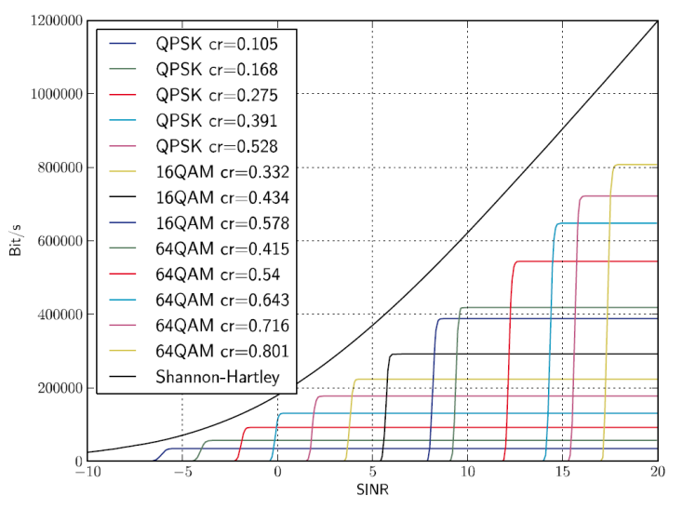

Figure 3.3 : Mapping of SINR to Data Rate [3]

**Radio Resource Assignment Algorithms**

As was shown in the previous chapter, in order to maximize CSE the cumulative throughput of all users should be maximized. The maximization is done using the radio resource assignment algorithms that are presented below.

* 1. **Assignment Algorithms**

The objective of assignment algorithms is to assign items Ci to another items Cj fulfilling specified initial conditions. Such conditions are known as the objective function. The goal of an algorithm is to find such a solution that will give the best suited assignment from the complete set of possible assignments [16].

At the same time, computational complexity of algorithms should be taken into account. The tradeoff between computational complexity and efficiency can create difficulties in deciding which algorithm should be used to solve the radio resource assignment problem.

Computational complexity varies for different algorithms and also depends on the number of cells and mobiles assigned to each BS serving the cell. There is also a difference in algorithm realization and principles for different numbers of BSs in the problem. For instance, an algorithm for two-dimensional problems can have different realization steps from the same algorithm for multi-dimensional problems.   
In this thesis resource fairness is assumed for each user, as well as the same number of UTs for every BS. It will result in a system with an equal amount of UTs in each cell, each getting the same amount of resources.

* 1. **Two-Dimensional Assignment**

For simulation scenario of two cells, each with *N* number of UTs, the input matrix *R* with *N2* entries. As the cumulated throughput should be maximized, each entry *ri,j* of *R* set is a sum of data rates of *i-*th and *j*-th UTs, such that they use the same sub-carriers and belong to different BSs.

The case of two cells will have to be dealt with two-dimensional assignment problem. An equal amount of elements in each dimension of the input matrix decreases the problem to Linear Sum Assignment Problem (LSAP) that can be solved by a fast polynomial-time algorithm [17].

Burkard [16] presents the LSAP problem by giving the following example:

The original model consists of *n* items (jobs) that should be assigned to other n items (machines) in the best possible combination. A cost function *cij* is associated with assignment of job *i* to machine *j*. The goal is to find such a combination of jobs with machines (assignment *f*) that minimizes total cost and can be presented as a function:

(4.2)



The analogy between this model and simulation scenario in this thesis can be observed. The differences can be formulated as follows:

* The objective function has to be maximized, so the term utility is used rather than cost.
* Utility function is uplink throughput.
* Items are represented by UTs.

As was discussed in chapter 4.1, the goal of the assignment algorithm is to find an assignment matrix *A* so that the cumulated throughput is maximized. In the case of two-dimensional assignment will be a matrix with entries *ai.j* , known as permutation matrix [16].

The mathematical representation of the optimization problem for two cells scenario, therefore, can be given as:



(4.3)

*Where A is a permutation matrix; 2 shows that there are two cells in the system; N is a number of UTs for each cell; Ths,n is throughput of n-th UT in s-th cell.*

*Permutation matrix is characterized by the system of equations:*



, for all j (4.4)



, for all i (4.5)

*and condition:*



(4.6)

*Where ai.j is equal to one when i-th UTof BS1 and j-th UT of BS2 use the same resources. Equations 4.4 and 4.5 shows, that each UT can be scheduled only once.*

In Figure 4.1 an example of the two-dimensional problem with N UTs is shown.

Input Matrix *R*: Assignment Matrix *A:* Example of *A:*





Figure 4.1: Example for the two-dimensional problem with N UTs

* 1. **Multidimensional Assignment**

For more than two cells the problem is extended to multiple dimensions. The input set R and assignment set A are hypermatrices with dimensions S, where S is the number of cells in the system.

The mathematical representation of the optimization problem for multi cells scenario, therefore, can be given as:



(4.7)

As multi-index assignment problems are Non-deterministic Polynomial-time Hard (NP-hard) they require a good heuristic algorithm, which should result in a near optimal solution within a reasonable amount of time [17]. Examples of heuristic algorithms are Greedy and Maximum Regret algorithms described in 4.4 and 4.5 chapters.

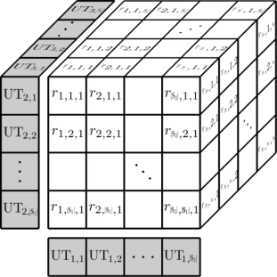

Figure 4.2: Example for the multi-dimensional problem with N UTs [8].

* 1. **Hungarian or Munkres Algorithm**

For the high number of N it is computationally unfeasible to use the Brute Force method that checks all possible assignments one-by-one, because (N!)S-1 different combinations should be checked [18]. However, an optimal solution in the polynomial time is available for two-dimensional problems using the Hungarian algorithm, introduced by H.Kuhl [19] and improved by Munkres [20].

* + 1. **Implementation of Hungarian or Munkres Algorithm**

Detailed description of the steps of the Hungarian Algorithm was taken from [3], [20] and [21] and is presented below. An example is given for input set *R* and is used further as an example input set for each algorithm:



**Step 1:**

1. Let set *L={ }* be the assignment vector, which reflect the solution of the algorithm.
2. The maximum assignment problem in the thesis should be converted into the minimum assignment problem for which the Hungarian algorithm was developed. For this purpose, find the maximum of all entries *rmax* in the complete input set and recalculate the matrix as*: rij= rmax - rij.*
3. Subtract the minimum value *rmin_row(i)* of each row from each element in this row.
4. For resulting matrix (after step 1.b) subtract the minimum value *rmin_column(j)* of each column from each element in this column.
5. *rmax = 40 b) rmin_row = {0, 2, 1, 9} c) rmin_column = {0, 23, 0, 13}*

**Step 2:**

1. Consider a zero in the resulting matrix.
2. If there is no zero yet, marked with a star, in its row and column, mark this zero (0*).
3. Repeat steps 2.a-b for every zero of the matrix.
4. Cover every column that has 0*.
5. If all the columns are covered, positions of zeroes, marked with star, indicate locations of optimal assignments, and the algorithm can be exited. Otherwise, proceed to step 3.



**Step 3:**

1. Find an uncovered zero and prime it (0’).
2. Check the row containing 0’. If there is no 0* in this row proceed to step 4.
3. If there is 0* in the row containing 0’, cover this row and uncover the column with 0*.
4. Repeat step 3.a-c until all zeros are covered and go to step 5.



**Step 4:**

1. Construct the series using following rules:

* Let Z0 be the uncovered 0’ found in step 3
* If there is a 0* in the column with Z0, let this 0* be Z1
* Let Z2be a 0’ in the row with Z1
* Continue the same procedure until there will be no 0* in the column with 0’

1. Remove the stars from every 0* and star every primed zero.
2. Erase all primes and uncover every line. Return to step 2.d.



**Step 5:**

1. Find the smallest uncovered value of the matrix.
2. Add this value to every covered row and subtract it from every value of uncovered columns.
3. Remove all primes, stars, covered lines and return to step 2.d.



*Optimal solution = {27, 38, 16, 31}*

* + 1. **Computational complexity of Hungarian or Munkres Algorithm**

The Hungarian algorithm was a topic of research for many scientists over the years, who managed to decrease its computational complexity. Hungarian algorithm, depending on the implementation can have computational complexity from *O(n4) to O(n3)* [22].

* 1. **Greedy Heuristic Algorithm**

According to [23], greedy algorithm can be applied to problems in which a set of choices have to be made to get the final result. The intention of Greedy is to find the global optimal solution from a set of local optimums [24]. In many cases greedy algorithm results in an optimal or good approximation to an optimal solution. However, this may not always be true. This happens because most of good values are already covered closer to the end of the algorithm execution, but selections, made earlier, are non-reversible. Consequently, the effectiveness of the algorithm should be tested for specific cases.

* + 1. **Implementation of Greedy Heuristic Algorithm**

Steps of the algorithm and example for the set *R* are shown below [8]:

1. Let set *L={ }* be the assignment vector, which reflect the solution of the algorithm.
2. Find the maximum of all uncovered elements in input matrix *R*, add it to solution set *L*.
3. Cover the row and the column containing this maximum.
4. If the size of *L* is equal to size of input matrix, exit the algorithm, otherwise, return to step b.



*L= {40} L={40, 39} L={40, 39, 15} L= {40, 39, 15 ,8}*

An example provided shows how Greedy algorithm performs for two-dimensional problems. The algorithm can also be used for multi-dimensional problems. Steps are the same, as described above with the only difference in step *c*:

*c)* Cover all the entries of the input matrix with the same index positions as the maximum has.

Three-cell problem with N UTs in each cell is shown on Figure 4.3.



Figure 4.3: Three-cell problem with N UTs in each cell.

* + 1. **Computational Complexity of Greedy Heuristic Algorithm**

An advantage of Greedy is its low computational complexity [4] that can be expressed as:



(4.8)

* *The solution set has N number of entries, where N is a number of UTs per cell, consequently N repetitions of the algorithm are required: summation from 0 to n-1.*
* *In first repetition NS search operations are required, as an input set has NS entries, where S is a number of cells in the system*
* *Every consequent repetition requires (N-i)S search operations*

Unsorted procedure to search the maximum can be substituted with sorted procedure. Sorting is the procedure that puts elements of the set in the required order (for instance, from biggest to smallest). The mean complexity of this procedure for input set with size *N* varies from *N*log2(N)* to *N*N!* depending on the implementation, but for the fasters case is equal to *N*log2(N).* Such a substitution is efficient if many selections have to be done from the set. For example, in cases, were there is a need to find first ten maximums in the same set, instead of making ten separate searches of maximums, sorting can be done and followed by extracting first ten values of the sorted array [25],[26].

If instead of the unsorted search sorted search is used, the computational complexity of Greedy can be expressed as:



(4.9)

* *Instead of N repetitions of the maximum selection, one sorting of the input matrix is needed.*
* *After sorting is done, N selections of maximum value from sorted array are needed.*
  1. **Maximum-Regret Heuristic Algorithm**

Maximum Regret algorithm is based on computation of max regret value *ri*, that reflects the competition between two highest values for a given index *i*and can be calculated as [18]:



(4.10)

*Where* *- maximum value* *for a given nonzero index i;**- second maximum value* *for a given nonzero index i*

* + 1. **Implementation of Maximum-Regret Heuristic Algorithm**

Maximum regret can be executed as follows for the input set *S*:

1. Let set *L={ }* be the assignment vector, which reflect the solution of the algorithm.
2. For each uncovered row find two highest values **and ** such that **and calculate their regret*: .*



1. For each uncovered column find two highest values **and ** such that **and calculate their regret: .



1. Find the maximum regret of all calculated regrets.
2. Add the ** ,forming the maximum regret, to the set *L* and cover the row and the column containing *.* If the size of the set L is not equal to the size of the input matrix *R*, go to step b*,* otherwise exit the algorithm.

An example for Maximum Regret algorithm using the example set *R* is shown below:



*Maximum Regret solution = {39, 31, 27, 4}*

For multi-index problems two possible implementations of Maximum Regret Algorithm were investigated: Maximum Regret Divided and Maximum Regret user oriented. The last one was originally proposed by Robertson and is known as Multi Dimensional Maximum Regret algorithm [27].

**Maximum Regret Multi Dimensional.**

The previously presented two-dimensional Maximum Regret algorithm should be modified as follows:

* Maximum regret is calculated for one fixed index position (in total SN regrets in the input set R). It will result in the user oriented Maximum Regret as one index position reflects one UT of one BS.

For three cells scenario one index position has to be fixed and two positions will vary.

For four cells scenario one index position has to be fixed and three positions will vary. An example for three and four cells scenarios is shown in the Figure 4.4.

**Three Cells :**

Three- index dimensions of assignments *ri,j,g* :

*i –UT belonging to BS1*, *i={0…N}*

*j –UT belonging to BS2*, *j={0…N}*

*g –UT belonging to BS3*, *g={0…N}*





*1. Fix i-th positition r(i, :, :)*

*2. Fix j-th position r(:,j,:)*

*3. Fix g-th position r(:,:,g)*

**Four Cells :**

Three- index dimensions of assignments *ri,j,g,h* :

*i –UT belonging to BS1*, *i={0…N}*

*j –UT belonging to BS2*, *j={0…N}*

*g –UT belonging to BS3*, *g={0…N}*

*h –UT belonging to BS4*, *h={0…N}*

*1. Fix i-th positition r(i, :, :,:)*

*2. Fix j-th position r(:,j,:,:)*

*3. Fix g-th position r(:,:,g,:)*

*4. Fix g-th position r(:,:,:,h)*

*MaxRegret= max (S*N regrets)*

*Size of each set in which regret should be found: NS-1*

Figure 4.4: Maximum Regret Multi Dimensional

* Not only row and column of local matrix, but also all the entries of input matrix with the same index positions, as the chosen value with the highest regret has, should be covered.

**Maximum Regret Divided.**

The idea of the method is to find local maximum regrets separately for different numbers of fixed positions. The maximum of these regrets, for each user (or fixed index position), is calculated first, and then maximum among regrets for each user is chosen. It will give us the maximum regret for the whole input set. In this case, not one, but two or more index position can be fixed. An example for four cells scenario with different number of fixed positions is shown in the Figure 4.5.

**4 Cells :**

Three- index dimensions of assignments *ri,j,g,h* :

*i –UT belonging to BS1*, *i={0…N}*

*j –UT belonging to BS2*, *j={0…N}*

*g –UT belonging to BS3*, *g={0…N}*

*h –UT belonging to BS4*, *h={0…N}*



**Two fixed positions:**

*1. Fix i-th and j-th positition r(i, j, :,:)*

*2. Fix i-th and g-th position r(i,:,g,:)*

*…*



*MaxRegret= max of regrets*

*Size of each set in which regret should be found: NS-2*

 **Three fixed positions:**

*1. Fix i-th, j-th and g-th positition r(i, j, g,:)*

*2. Fix i-th, g-th and h-th position r(i,:,g,h)*

*…*



*MaxRegret= max of regrets*

*Size of each set in which regret should be found: NS-3*



*MaxRegret= max of regrets, where p is a number of fixed positions*

*Size of each set in which regret should be found: NS-p*

Figure 4.5: Maximum Regret Divided and Maximum Regret User Oriented Method

* + 1. **Computational Complexity of Maximum Regret Heuristic Algorithm**

The difference between unsorted and sorted procedures to select maximums was explained in the Section 4.4.2. Computational complexity for Maximum Regret algorithms using both procedures is presented below.

**Maximum Regret Multi Dimensional: Unsorted**



(4.11)

* *Solution set has N entries, where N is the number of UTs per BS. Consequently, N repetitions of the algorithm are required: summation from 0 to N-1.*
* *In each repetition the selection of maximum regret should be done for each fixed index position separately.*
* *For the first repetition it will result in S*N times search in sets of size NS-1. Each maximum regret search requires 2 selections: first and second maximum.*
* *Every consequent repetition requires 2*(N-i) search operations in sets of size (N-i)S-1*

**Maximum Regret Multi Dimensional: Sorted**



(4.12)

* *Instead of N repetitions of selection procedure, one sorting of input matrix is needed, separately for every index position. It will result in S*N sorting procedures, each*

*(N)S-1*log((N)S-1) steps, because there are S*N index positions, each containing (N)S-1entries.*

* *After sorting is done, selections of maximum regret value from sorted arrays have to be done N times for every index position.*

**Maximum Regret Divided:**

Figure 4.5 shows that computational complexity of unsorted Maximum Regret Divided can be calculated as:



(4.13)

*Where p is a number of fixed index positions*

* *Solution set has N entries, where N is a number of UTs per BS. Consequently N repetitions of the algorithm are required: summation from 0 to N-1.*
* *In each repetition the selection of maximum regret should be done for p fixed index position separately.*
* *For the first repetition it will result in times search in sets of size NS-p. Each*



*maximum regret search requires 2 selections: first and second maximum.*



* *Every consequent repetition requires search operations in sets of size (N-i)S-1*

**4.7. Conclusion**

The differences between algorithms, described in the present chapter, are summarized in the Table 4.1. Figure 4.6 gives a graphical representation of differences in the computational complexity for Greedy and Maximum Regret Multi Dimensional algorithms, both for unsorted and sorted search.

Table 4.1: Difference between algorithms

|  |  |  |
| --- | --- | --- |
| Algorithm | Resulting Set for Used Example | Computational Complexity for Multi-dimensional Problems |
| Random |  | *N* |
| Brute Force | *L= {27, 38, 16, 31}* | *(N!)S-1* |
| Hungarian or Munkres | *L= {27, 38, 16, 31}* | *-* |
| Greedy Heuristic | *L= {40, 39, 15 ,8}* | Selection :  Sorting: |
| Maximum Regret Multi Dimensional | *L= {39, 31, 27, 4}* | Selection:  Sorting: |
| Maximum Regret Divided |  |  |

The Table 4.2 shows the breakeven point for algorithms, when sorted procedure starts to perform better than unsorted, for two-, three- and four-cell scenarios. The table 4.2 supports the decision to use unsorted procedure for a small number of UTs in the system, however, when the number of UTs in the system is increased, sorting starts to perform better in terms of runtime, especially for Greedy algorithm and two-cell scenario.



(a) 2 BS, 2-100 UTs (b) 3 BS, 2-100 UTs

Figure 4.6 : Number of operations versus number of UTs for two and three BSs

Table 4.2: Breakeven point for Greedy and Maximum Regret

|  |  |  |  |
| --- | --- | --- | --- |
| Algorithm | 2 BSs | 3 BSs | 4 BSs |
| Maximum Regret User Oriented | 3 UTs | 14 UTs | 37 UTs |
| Greedy | 27 UTs | 72 UTs | 140 UTs |

In Figure 4.7 a comparison of computational complexity of Maximum Regrets for different number of fixed index positions is shown. For *p=x* and *p=S-x* (where p is the number of fixed positions, x –is an integer number and S is the number of cells in the system) there is no difference in the computational complexity. The lowest computational complexity for Maximum Regret can be achieved for fixed one or *S-1* index positions.

The Figure 4.8 shows the difference between Maximum Regret and Brute Force. Brute force computational complexity grows much faster than slowest of all described Maximum Regrets.



Figure 4.7: Number of operations versus number of UTs for Maximum Regret Algorithm with Different Number of Fixed Index Positions (seven BS)



Figure 4.8: Computational complexity of Maximum Regret versus Brute Force

1. **Simulation Scenario**

As was already pointed out in the Section 1.2, uplink results are evaluated in this thesis. The focus of this thesis lies on grouping UTs from different cells that should transmit on the same resources. As the simulation environment MatLab was chosen. In this chapter a scenario description, as well as simulation parameters are presented.

* 1. **Simulation Scenario**

In Figure 5.1 the simulation scenario for three cells is shown. Although in the thesis simulation was implemented for two, three and four cells in the system, the same logic can be used for scenarios with more cells as well.

The cell has a circular form with radius *rcell* and a BS in the center. Cells are separated by inter-cell edge distance *dinter*. When *dinter*is equal to *rcell*, the complete overlap of cells can be observed. Every cell has equal number of UTs, distributed randomly within the cell area. The coordinates *(xi, yi)*of each BS can be calculated as [8]:



(5.1)



*Where S is the total number of cells in the system, rBS is the radius of the circle on which BSs are placed and can be expressed as follows:*



(5.2)



Figure 5.1: Simulation scenario with three cells and two UTs in each cell

Example of described scenario are presented in the Figure 5.2.



Figure 5.2: Example scenario for three Cells, 200 UTs in each cell and rcell=100m, dinter= 0m

* 1. **Simulation Parameters and Configurations**

The simulation parameters were chosen based on to the Report ITU-R M.2135 [28].

Transmission power is assumed to be the same for every user in every cell. Resource fairness is chosen for this thesis as decision strategy about the amount of resources each user should get (see Section 3.3.1). This means that every user gets the same number of RBs.

As pathloss model Indoor Hotspot Non line-of-site (InH NLoS) scenario is chosen:

(5.3)



*Where d is the distance from UT to BS, fc is the center frequency.*

Each cell contains the same number of users N and has radios rcell =100m. Results are presented for 2, 4, 6 and 8 UTs and dinter from -100m to 100m. Such a choice is realistic for the scenario with households in suburban areas, apartment houses, and etc. Apartments of households are located in the neighborhood to each other and each house owner has a full freedom to place BSs wherever possible, therefore creating either overlapping of cells or complete separation. Configuration and simulation parameters are summarized in the Table 5.1.

Table 5.1: Configuration and Simulation Parameters

|  |  |
| --- | --- |
| Parameter | Value |
| Number of Cells | 2, 3, 4 |
| Number of active UTs per Cell | 2, 4, 6, 8 |
| Inter-cell Edge Distance dinter | -100m, -75m, -50m, -25m, 0m, 50m |
| Pathloss Model | InH NLoS |
| Cell Radius rcell | 100m |
| System Bandwidth | 20 MHz |
| Subcarrier Spacing | 15000 Hz |
| Subcarrier per Subchannel | 12 |
| Frame length | 1ms |
| Subframes per Frame | 10 |
| Fast Fading | disabled |
| Thermal Noise | Neglected (see Section 3.3.3) |
| Receiver Noise | Neglected (see Section 3.3.3) |
| UTs distribution inside the Cell | Random uniform |

1. **Simulation Results**

In this chapter simulation results are presented. The simulation scenario is configured as is described in the Chapter 5. Analysis of results starts with an investigation of the uplink throughput per UT and proceeds with comparison in gain over the Random Strategy for different assignment algorithms. The chapter also provides results of the simulation runtime and the percentage of wins for every algorithm used. Every simulation was done for different number of drops (from 3000 to 10000). The number of drops was chosen to provide fluctuations from the mean not more than 0.2% for the 95% confidence interval (Figure 6.3-6.5). As UTs are random uniform distributed, in each drop they are placed at different positions.

* 1. **Uplink Throughput Comparison**

For two cell scenario results are produced for Greedy, Random, Maximum Regret (MaxReg) and Hungarian (Hung) assignment strategies.



(a) 2UT (b) 4UT



(c) 6UT (d) 8UT

Figure 6.1: CDF of the Uplink Throughput in two cell scenario with dinter=-75m

Maximum Regret User (MaxRegUser) and Maximum Regret Divided (MaxRegDiv) in this case of 2 cells are the same, as the input set has only two dimensions. Hung algorithm for two cells scenario gives an optimal solution, as was discussed in Section 4.4. Figure 6.1 shows the Cumulative Distribution Function (CDF) of the uplink throughput per UT averaged over all drops for the two cell scenario with inter-cell edge distance dinter of -75m, which is average case setting regarding interference, and different number of UTs in the cell. The step form of the graphs results from the finite amount of throughputs after the mapping of effective SINR to 14 MCSs (see Section 3.2.4). The difference between algorithms performance is growing with the number of UTs in the cell as the size of input set is also growing.

In the low throughput ranges Random algorithm shows the best performance, however it decreases with a movement towards the higher throughput ranges, especially for the high number of UTs. Greedy strategy shows much better results than Random in the higher throughput ranges, but slightly worse than MaxReg and Hung. Performance of MaxReg strategy is similar to Hung for 2 and 4 UTs in the cell, however it moves from the Hung towards the Greedy performance with the increasing number of UTs. For Random strategy users in the lower throughput ranges will achieve lower throughputs than for Hungarian, and users in the higher throughput ranges will have higher throughputs.

In Figure 5.2 the CDFs of the uplink throughput per UT averaged over all drops for different number of cells are plotted. The CDF is calculated for Random, Greedy, Maximum Regret Divided (MaxRegDiv), Maximum Regret Multi Dimensional (MaxRegUser) and Best Random (BestRand) is presented. BestRand is the multiple repetition of Random algorithm with the selected best result from all the repetitions performed. Such a strategy gives an estimation of the optimal solution. However, with the increased amount of UTs and BSs in the system, there is a need to increase the amount of repetitions increase the probability of having optimal or close to the optimum.

For the complete overlapping of cells (dinter=-100m) there are more users in the system who transmit in the lower throughput ranges. With the increase of the inter-cell edge distance, the impact of interference vanishes and all users use the best possible MCS. This effect is observed in two cell scenario for dinter higher than 90m, for three cell scenario for dinter higher than 70m, and for four cell scenario for dinter higher than 30m.

* 1. **Cell Spectral Efficiency**

The CSE is calculated using the Formula 3.6. In Figures 6.3-6.4 absolute values of CSE are presented for 2,3, and 4 cells scenarios. In general from the graphs it can be seen that CSE is higher for larger number of cells in simulation scenario for every dinter and achieves maximum of 4.4856 bit/s/Hz/cell with smaller dinter.



 (a) 2 BS, 4UT, dinter= -100m (b) 2 BS, 4UT, dinter= 90m

(c) 3 BS, 4UT, dinter= -100m (d) 3 BS, 4UT, dinter= 70m



(e) 4 BS, 4UT, dinter= -100m (f) 4 BS, 4UT, dinter= 30m

Figure 6.2: CDF of the Unlink Throughput for different number of cells



(a) 2UT (b) 4UT



(c) 6UT (d) 8UT

 Figure 6.3: CSE in two cell scenario versus dinter



(a) 3BS (b) 4BS

Figure 6.4: CSE in four UT scenario versus dinter

Random always performs worse than all other strategies in terms of CSE. With the increasing number of UTs the difference between CSE using Random strategy and using other assignment strategies increases, showing that the decision of which assignment strategy to use is more critical for higher numbers of users in the system.

(a) 2UT (b) 4UT

(c) 8UT

Figure 6.5: Percentage of Victories versus Number of UTs in two cell scenario for different Inter-cell Edge Distances

In Figures 6.5-6.7 the percentage of victories of evaluated algorithms are shown for 2, 3, and 4 cell problems. Percentage of victories reflects the percentage of won by an algorithm simulation drops. The algorithm wins the simulation drop when it shows the highest CSE among all the algorithms used in the simulation. In general, graphs plotted in Figures 6.5-6.7 support already pointed conclusion that Random strategy always performs worse than others in terms of CSE.

In the case of two cell scenario MaxReg wins more often than Greedy strategy, especially for higher dinter. The difference between algorithms also increases with a growing number of UTs in the cell because the distribution of entries in the input set also changes. For higher dinter there will be more entries with higher data rates than lower data rates as can be seen from Figures 6.1 and 6.2. For 2 cell scenario CSE achieves maximum when dinter becomes greater than 90m. In this point does not matter anymore which algorithm to use and it is reflected in the graph as a convergence of all the algorithms in point 33.3 %.

(a) 2UT (b) 4UT

(c) 6UT

Figure 6.6: Percentage of Victories versus Number of UTs in three cell scenario for different Inter-cell Edge Distances

For three cell scenario Greedy usually shows significantly smaller percentage of victories than both Maximum Regret strategies, except for the high inter-cell interference case of the complete overlapping of cells and the case with dinter > 70m, when there is almost no difference between algorithms in number of wins. MaxRegDiv shows better results for dinter> -25m, whereas MaxRegUser outperform for dinter< -25m. The convergence of algorithms achieved at around 70m in the point of 25%.

From Figure 6.8 the percentage of victories is shown for simulation scenario of three cells with four UTs and dinter=-50m. It can be seen that already for 300 drops results achieve approximately stabile values of 45% for MaxRegDiv, 39% for MaxRegUser, 12.5% for Greedy and 3.5% for Random. This matches the values for dinter=-50m presented in Graph 6.6(b). As 500000 drops are used for simulation it proves the confidence in results presented in Figures 6.5-6.7.

Four cell scenario is similar to Three cell scenario, but MaxRegDiv starts to outperform MaxRegUser after dinter = -75m and with the higher degree of difference if to compare with three cell scenario. This is reflected by larger divergence of lines in graphs. The convergence of algorithms is observed near dinter=30m in the point of 25%.

(a) 2UT (b) 4UT

(c) 6UT

Figure 6.7: Percentage of Victories versus Inter-cell Edge Distances in Four Cell Scenario for different Number of UTs



Figure 6.8: Percentage of Victories versus Number of drops in three cell scenario with four UTs and dinter=-50m

(a) dinter=-100m (b) dinter=50m

(c) dinter=0m (d) dinter=50m

Figure 6.9: Gain over Random Strategy versus Number of UTs in two cell scenario for different Inter-cell Edge Distances

(a) 3BS (b) 4BS

Figure 6.10: Gain over Random Strategy versus Number of UTs in three and four cell scenario and dinter=-50m

The gain in CSE over the Random Strategy versus number of UTs is shown in Figures 6.9-6.10 for a two, three and four cell scenario.

Figure 6.9 shows the two cell scenario over inter cell edge distance dinter. The graphs presented here are supporting the information that was provided above about percentage of victories in the Figure 6.5. Hung strategy is providing an optimal solution and is performing as an upper bound of possible gain for all other algorithms. The clear trend towards improvement in gain with the increasing number of UTs in the cell can be observed in general for every graph. With the growing distance dinter  and fixed number of cells and UTs in scenario the gain is decreasing.

MaxReg strategy shows slightly worse results than Hung, but this difference is growing with the growing amount of UTs in the cell.

Greedy results are very close to the upper bound in scenario with a complete overlap of cells. The difference between performance of Greedy and other algorithms is growing with an increasing inter-cell edge distance. However, as the gain in CSE for high dinter is relatively small, this deterioration of Greedy results can be neglected.

In the Figure 6.8 the gain over Random strategy for Greedy, MaxRegDiv (for S-1 fixed index positions), Maximum MaxRegUser and BestRand is presented. BestRand is the best solution found when Random is repeaded multiple times. In this thesis, Random was repeated 1000 times due to simulation time constraints. For small number of UTs and BSs in the system 1000 is an optimal solution with a very high probability, however, with a growing amount of UTs in the system, the probability to find an optimal solution using RandRep decreases. It can also be observed from simulation results.

(a) 3BS (b) 4BS

Figure 6.11: Percentage of Victories versus Number of UTs in three and four cell scenario with dinter=-50m

(a) dinter=-100m (b) dinter=-50m

(c) dinter=0m

Figure 6.12: Gain over Random Strategy versus Number of cells for four UTs in the cell

Number of drops that were used to plot graph (a) in Figure 6.10 are not enough to judge about the performance of MaxRegDiv versus MaxRegUser. However, the mean value of MaxRegUser is slightly better than MaxRegDiv in general and for dinter=-50m. This is also supported by Figure 6.11(a), where the percentage of victories versus number of UTs is presented for three cell scenario with dinter=-50m. Consequently, usually, during one drop MaxRegUser is better than MaxRegDiv. But if to compare drops with each other, MaxRegUser in one drop can show worse results than MaxRegDiv in another drop.

For the case of dinter=-100m MaxRegUser shows slightly better results than MaxRegDiv, nevertheless for dinter=0m MaxRegDiv performs better than MaxRegUser strategy. Greedy in general has a lower gain than Maximum Regret.

Scenario with four cells is similar to the scenario with three cells, however, MaxRegDiv is showing better results than MaxRegUser already for dinter=-50m.This difference is further increasing with a number of UTs in the cell because the amount of calculated local regrets is growing much faster for MaxRegDiv than for MaxRegUser with increasing number of cells and UTs in the system. It is reflected by increasing gap between lines MaxRegDiv and MaxRegUser in the Graph 6.10(b).

Figure 6.12 shows the difference in gain over Random strategy versus number of cells in the system for different inter-cell edge distances for four UTs in every cell. In general, gain decreases with the increasing number of cells and fixed number of UTs in the system.

* 1. **Runtime**

As was already mentioned above the TTI in LTE advanced has a length of 1ms. The scheduling has to be performed every TTI. This imposes restrictions on the time available for the computation while solving the radio resource assignment problem. If to form the superframe that includes several TTI this limitation can be relaxed. In home scenario users are not moving fast, consequently the probability of sudden change of the channel quality is low [8].

The runtime for assignment calculation for different algorithms versus the number of UTs in the cell is presented in Figure 6.13. Results are simulated using the Core I5 CPU with 3.20 GHz with architecture x86-32. The run time can be further improved using faster processors or parallel computing and, potentially, by optimizing the code.

The runtime increases with the number of cells and with the number of UTs in the cells. The fastest algorithm is Random that in simulation scenario does not reach the limit of 1ms. The second in computational runtime performance is Greedy algorithm that in worst presented case has a runtime of about 0.6ms, that matches theoretical complexity of Greedy shown in Figure 4.6.

For 2 cell scenario Maximum Regret and Hungarian strategy runtime crosses 1ms boundary with ten UTs in the cell, that is very similar to the theoretical result presented in Figure 4.6(a) for Maximum Regret. For less than eight UTs Maximum Regret is faster than Hungarian, but for more than 8 UTs the breakeven point occurs and Hungarian forging ahead.

(a) 2 BS (b) 3 BS

(c ) 4 BS

Figure 6.13: Runtime versus Number of UTs in the cell

Although in theory Maximum Regret for one and *S-1* fixed index positions perform the same in terms of runtime, in the real scenario presented in this thesis MaxRegUser is faster than MaxRegDiv. It is connected with realization of the code. For MaxRegDiv local regrets are calculated first, and then – maximum of all local regrets for every fixed index position. However, for MaxRegUser, maximum regrets of every fixed position can be found from the beginning.

For three cells MaxRegDiv exceeds 1ms already for three UTs, whereas MaxRegUser crosses the limit with five UTs in the cell. For four cells this number decreases to three UTs, showing that Maximum Regret Strategies are much slower relatively to the Greedy and Random.

1. **Summary**

In this thesis the analysis of different radio resource allocation strategies for scheduling in LTE-Advanced is performed. Random Strategy and optimal solution are compared with heuristic algorithms in terms of CSE and runtime. The model of the network is simulated in MatLab.

* 1. **Conclusions**

According to results in Chapter 6 following conclusions can be drawn:

* With the increase of the inter-cell edge distance, the impact of interference vanishes and all users use the best possible MCS. This effect is observed in two cell scenario for dinter higher than 90m, for three cell scenario for dinter higher than 70m, and for four cell scenario for dinter higher than 30m.
* CSE can be increased significantly if instead of Random assignment algorithm to use heuristic algorithms such as Maximum Regret and Greedy. However, in general, heuristic algorithms are not giving an optimal solution.
* Runtime can be significantly decreased if instead of Brute Force use Heuristic algorithms, especially Greedy.
* CSE is higher for Maximum Regret than for Greedy (up to 5%) for four cells with 6UTs, but computational complexity in this case is approximately 1000 higher.
* Gain in CSE over Random decreases with the increasing number of cells and fixed other parameters.
* Gain in CSE over Random increases with the increasing dinter and fixed other parameters.
* Random and Greedy strategies do not reach runtime of 1ms even in the worst case scenario evaluated in the thesis (four cells with 10UTs).
* Maximum Regret Strategies are much slower relatively to the Greedy and Random. For two cell scenario runtime crosses 1ms boundary with ten UTs in the cell and for four cell scenario this number decreases to three UTs in the cell already, making Maximum Regret strategies impossible to be used in networks with high number of users and BSs in the system.
  1. **Outlook**

Suggestions for further research that can be an extension of this thesis are presented below:

* Model of Linear Assignment Problem is evaluated in which the same number of users in every cell is assumed. This assumption is not always realistic in real systems. Consequently, the model should be extended to include any number of UTs in different cells.
* Transmission power is assumed to be the same for every UT in this thesis. Therefore, power control can be done as an extension of simulation scenario.
* The performance of radio resource assignment algorithms was checked for a small number of users and BSs in the system. Further comparison of algorithms in scenarios with higher inter-cell edge distances, cell radius and number of UTs and cells can be done.
* In cases of outdoor scenarios fast fading, that is neglected in present scenario, can be added in the model.

**Bibliography**

[1] K. Safjan, V. D’Amico, D. Bültmann, D. Martin-Sancristian, A. Saadani , “Assesing 3GPP LTE-Advanced as IMT-Advanced Technology: The WINNER+ Evaluation Group Approach”, IEEE Communications Magazine, February, 2011

[2] 3GPP, Tech. Specific. Group Radio Access Network – Requirements for Evolved UTRA(E-UTRA) and Evolved UTRAN (E-UTRAN) , 3GPP TS 25.913

[3] K.Henzel, “Performance of a Heuristic Uplink Radio Resource Assignment Algorithm for LTE-Advanced”, ComNets Research Group, Faculty 6, RWTH Aachen University

[4] F. Capozzi, G. Piro, Student Member, IEEE, L.A. Grieco, Member, IEEE, G. Boggia, Senior Member, IEEE, and P. Camarda, “Downlink Packet Scheduling in LTE Cellular Networks: Key Design Issues and a Survey” ,IEEE Communications Magazine , 2013

[5] E. Dahlman, S. Parkvall, J. Skold, and P. Beming, 3G Evolution HSPA and LTE for Mobile Broadband. Academic Press, 2008.

[6] J.Zyren, “Overview of the 3GPP Long Term Evolution Physical Layer”, Freescale Semicondactor, July, 2007

[7] Stefan Parkvall, Erik Dahlman, Anders Furuskär, Ylva Jading, Magnus Olsson, Stefan Wänstedt, Kambiz Zangi , Ericsson Research, “LTE-Advanced – Evolving LTE towards IMT-Advanced”, IEEE Communications Magazine , 2008

[8] K.Henzel, “Design and Evaluation of Scheduling Algorithms for LTE Femtocells”, Diploma Thesis, ComNets Research Group, Faculty 6, RWTH Aachen University, September, 2011

[9] Amitava homas, Motorola Inc., “LTE-advanced: next-generation wireless broadband technology”, IEEE Wireless Communications, June 2010

[10] J.Zyren, “Overview of the 3GPP Long Term Evolution Physical Layer”, Freescale Semicondactor, July, 2007

[11] “Long Term Evolution Protocol Overview”, Freescale Semicondactor, October, 2008

[12] D. Laselva, F. Capozzi, F. Frederiksen, K. Pedersen, J. Wigard, and I. Kovacs, “On the Impact of Realistic Control Channel Constraints on QoS Provisioning in UTRAN LTE,” in Proc. IEEE Veh. Tech. Conf., VTC-Fall, Anchorage, Alaska, USA, Sep. 2009, pp. 1 –5.

[13] D. Sabella, M. Caretti, and R. Fantini, “Energy efﬁciency evaluation of state of the art packet scheduling algorithms for LTE,” in Proc. IEEE European Wireless Conf., EW, pp. 1–4, Apr. 2011.

[14] K.Brueninghaus, D. Astely, T.Salzer, S.Visuri, A.Alexiou, S.Karger and G.A. Seraji , “Link Performance Models for System Level Simulations of Broadband Radio Access Systems”, Personal, Indoor and Mobile Communicationa, 2005. PIMRC 2005. IEEE 16th International Symposium on, vol.4, pages 2306-2311

[15] ITU-R, “Requirements Related to Technical Performance for IMT-Advanced Radio Interface”, M.2134, 2008

# [16] [R. Burkard](http://www.amazon.com/s/ref=ntt_athr_dp_sr_1?_encoding=UTF8&field-author=Rainer%20Burkard&search-alias=books&sort=relevancerank), [M. Dell'Amico](http://www.amazon.com/s/ref=ntt_athr_dp_sr_2?_encoding=UTF8&field-author=Mauro%20Dell%27Amico&search-alias=books&sort=relevancerank) , [S. Martello](http://www.amazon.com/s/ref=ntt_athr_dp_sr_3?_encoding=UTF8&field-author=Silvano%20Martello&search-alias=books&sort=relevancerank), “Assignment Problems”,  Society for Industrial and Applied Mathematics , January 2009

[17] R.E. Burkard, E.Cela, “Linear Assignment Problems and Extensions”, Kluwer Academic Publishers, 1999

[18] A. J. Robertson“A Set of Greedy Randomized Adaptive Local Search Procedure (GRASP) Implementations for the Multidimensional Assignment Problem”, Kluwer Academic Publishers, Computational Optimization and Applications, 19, 145–164, 2001

[19] H.W. Kuhn, “The Hungarian Method for the Assignment Problem”, Naval Research Logistic Quarterly, Wiley, vol. 2, no.1, pp. 83-97. 1955

[20] J. Munkres, “Algorithms for the Assignment and Transportation Problems”, Journal of

the Society of Industrial and Applied Mathematics, 5(1):32-38, March 1957.

[21] F.Bourgeois, J. Lassalle, “An Extension of the Munkres Algorithm

for the Assignment Problem to Rectangular Matrices” ,Commun. ACM, 14:802-804, December 1971.

[22] A.Frank, On Kuhn’s, “Hungarian Method –A tribute from Hungary”, Egrervary Research Group, Budapest, Hungary, October, 2004

[23] T.H Cormen, h. Thomas, “Introduction to Algorithms”, 2nd. Ed. Massachusetts Institute of Technology, 2001

[24] P. Merz, B. Freisleben, “Greedy and Local Search Heuristics for Unconstrained Binary Quadratic Programming”, Department of Electrical Engineering and Computer Science (FB 12), University of Siegen, August, 2000

[25] [Donald Knuth](http://en.wikipedia.org/wiki/Donald_Knuth). [The Art of Computer Programming](http://en.wikipedia.org/wiki/The_Art_of_Computer_Programming), Volume 3: Sorting and Searching, Third Edition. Addison-Wesley, 1997. [ISBN 0-201-89685-0](http://en.wikipedia.org/wiki/Special:BookSources/0201896850). Section 5.3.3: Minimum-Comparison Selection, pp.207–219.

[26] Vandana Pushe, “Assortment of Different Sorting Algorithms”, Asian Journal Of Computer Science And Information Technology, 1: 5 (2011) 129 – 131.

[27] Robertson, Alexander J. “A Set of Greedy Randomized Adaptive Local Search Procedure (GRASP) Implementations for the Multidimensional Assignment Problem”, Computational Optimization and Applications, 19, 145-164, 2001

[28] ITU-R “” Guidelines for Evaluation of Radio Interface Technologies for IMT-Advanced, M.2135-1, December,2009